University of Wolverhampton
School of Mathematics and Computer Science
5CS022 Distribute and Cloud Systems Programming Week 2 Workshop Overview
The aim of this workshop is to build on the previous workshop with MPI and to carry out an assessed task.
You can carry out this workshop either the university servers: thinlinc.wlv.ac.uk or your own Linux system (if you prefer to use Putty to log in instead of the Thinlinc client, connect to the server tl-01.wlv.ac.uk instead). Tasks
1. The following C program sums up all the values in array "data" and displays the sum total.:
#include <stdio.h>
#define NUMDATA 10000 int data[NUMDATA];
void LoadData(int data[])
{ for(int i = 0; i < NUMDATA; i++){
data[i] = 1;
}
}
int AddUp(int data[], int count)
{ int sum = 0;
for(int i = 0; i < count; i++){
sum += data[i];
}
return sum;
}
int main(void) { int sum;
LoadData(data); sum = AddUp(data, NUMDATA);
printf("The total sum of data is %d\n", sum); return 0;
}
Convert it to MPI to run with any number of nodes including just one.

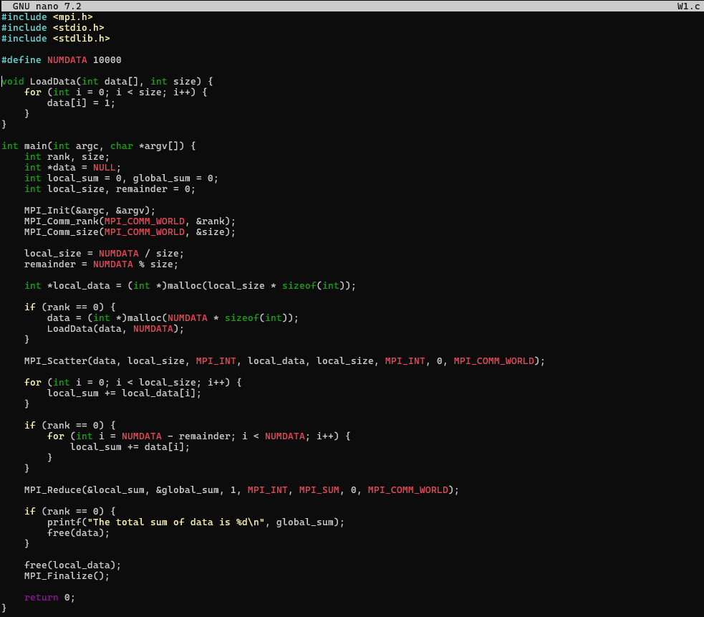
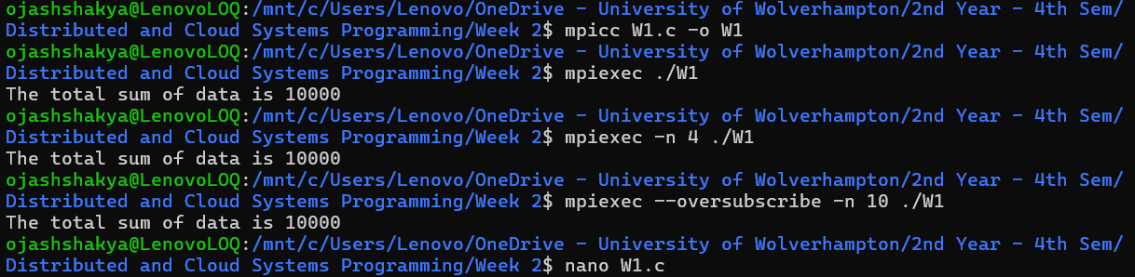

Explanation: This code distributes the task of adding up 10,000 elements in an array among several processes using MPI parallel processing. It gives advantage of size and rank. The MPI_Scatter Function is used to partition the whole data into discrete parts. Every procedure uses the AddUp function to determine the total amount of the received chink. MPI_Reduce is subsequently used to combine these parts.

- Write an MPI program called pingpong.c to run with exactly 2 processes. Process rank 0 is to send an integer variable called "ball" initialised with the value zero to Process rank 1. Process rank 1 will add 1 to the ball and send it back. This will repeat until the ball has a value of 10 in Process rank 0.
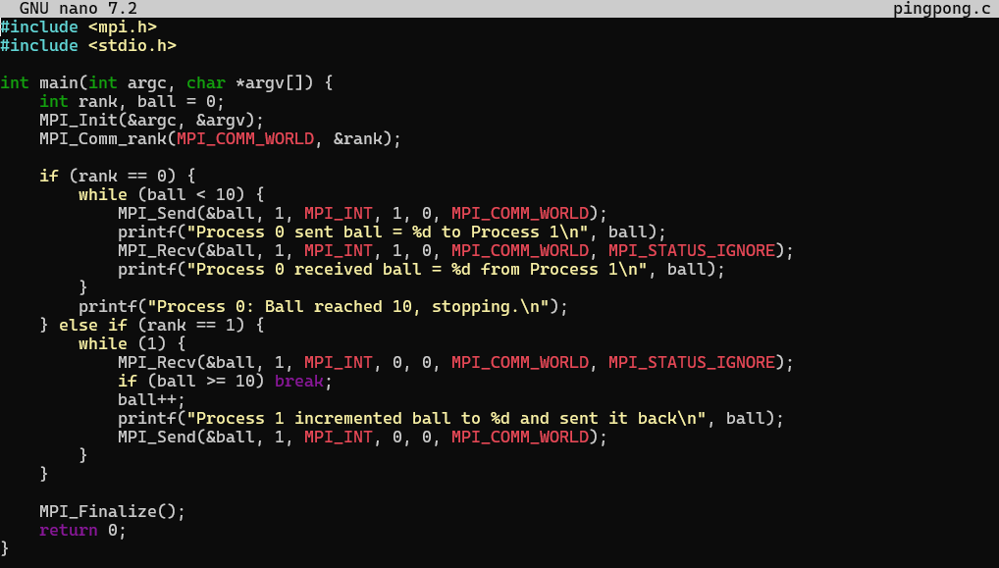
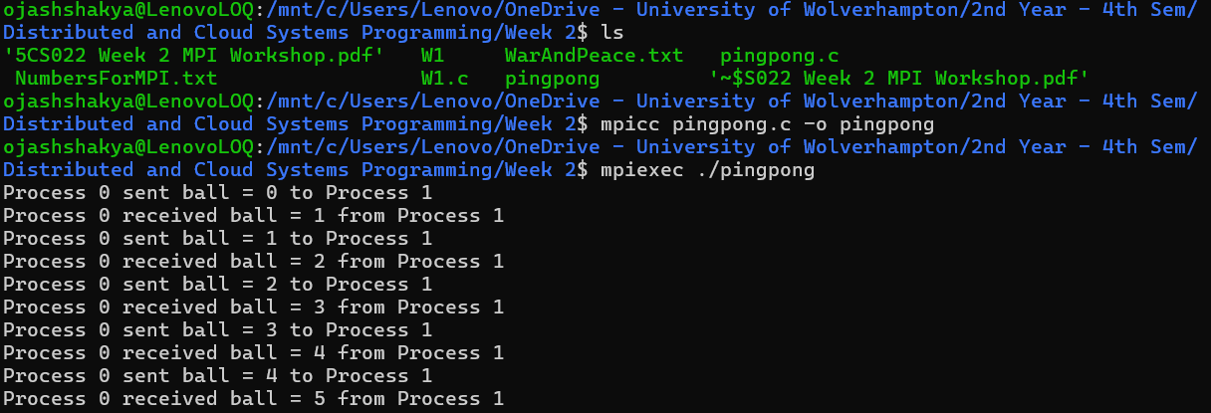
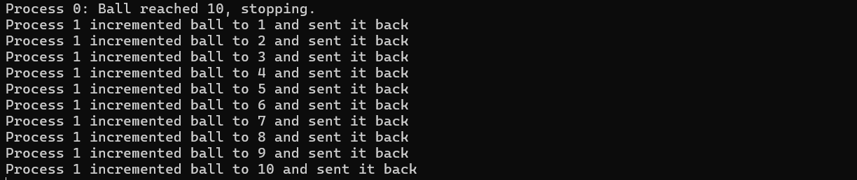
Explanation: This MPI program uses message passing to mimic a game of ping-pong between two processes, ranked 0 and 1. Process 0 initiates the process by sending a ball to Process 1, which uses MPI_Send and MPI_Recv to increase the ball and return it back. This conversation keeps going until the ball hits MAX_COUNT 10.

- Write a "Pass-the-parcel" MPI program that will run with 3 or more nodes, such that Process rank 0 will send an integer variable call "parcel" initialised with 1, to Process rank 1 which will add 1 to the parcel and then send it to Process rank 2, and so on until the highest rank process will send it back to Process rank 0, at which point the parcel variable should contain the value of the number of nodes there are.
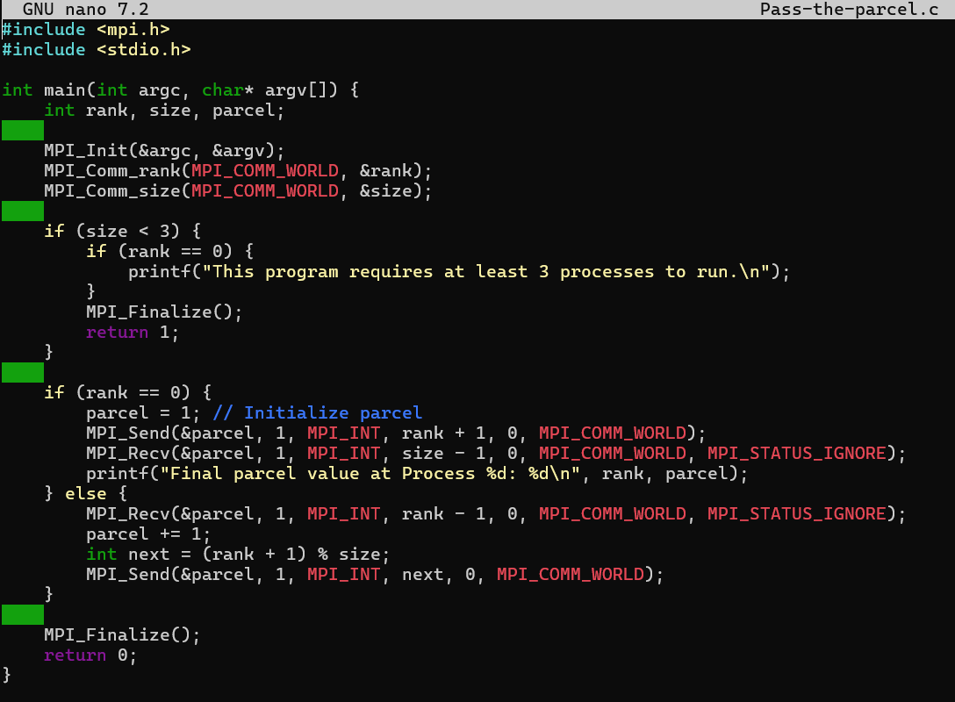
Explanation: With the help of at least three processes, the parcel is passed in this program's implementation of pass-the-parcel, rising in value each time. First, MPI is initialized. After initializing the parcel with 1, process 0 forwards it to process 1, which subsequently obtains the final value from the final process. After receiving the package from the previous rank, each step increases it before moving on to the next one. The final process prints the final value equal to the total number of processes after sending the last packet back to process 0.

- The following program has all the processes with rank greater than 0 send random amounts of data to Process rank 0 :
#include <mpi.h>
#include <stdio.h>
#include <stdlib.h> #define NUMDATA 1000
int main(int argc, char **argv)
{ int size; int rank; int tag=0; int count;
MPI_Status status; int data[NUMDATA];
MPI_Init(&argc, &argv);
MPI_Comm_size(MPI_COMM_WORLD, &size); MPI_Comm_rank(MPI_COMM_WORLD, &rank);
if (rank == 0){ for(int i = 0; i < size - 1; i++) {
MPI_Recv(data, NUMDATA, MPI_INT, MPI_ANY_SOURCE, MPI_ANY_TAG,
MPI_COMM_WORLD, &status);
MPI_Get_count(&status, MPI_INT, &count);
printf("Node ID: %d; tag: %d; MPI_Get_count: %d; \n", status.MPI_SOURCE, status.MPI_TAG, count);
}
} else {
MPI_Send(data, rand()%100, MPI_INT, 0, tag, MPI_COMM_WORLD);
}
MPI_Finalize(); return 0;
}
Modify it so that it doesn't use a fixed size data buffer but uses "malloc()" to allocate the correct amount of memory to use every time. Note this means that Process rank 0 will need to know what the amount of data it is expecting before it receives it.

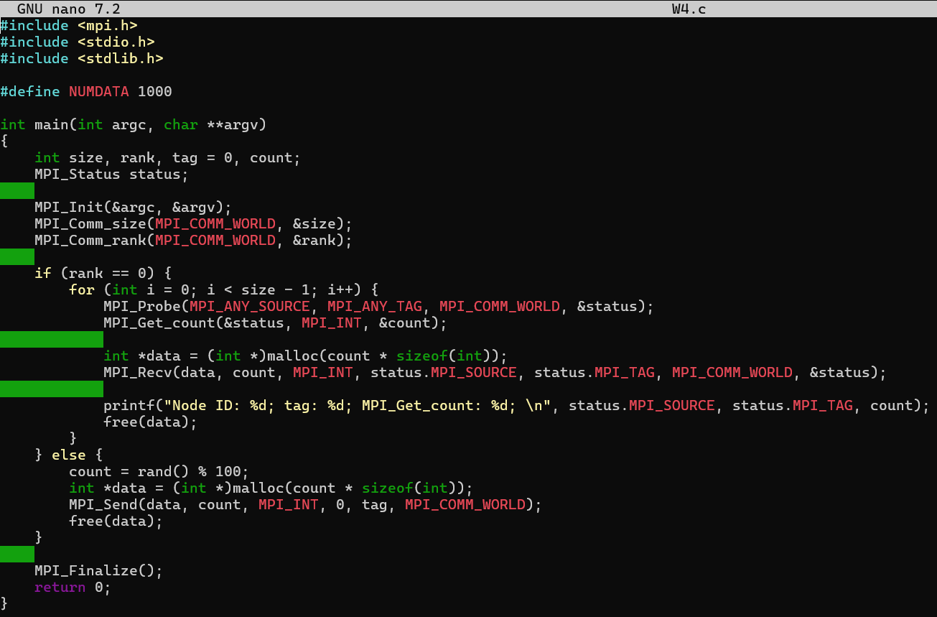
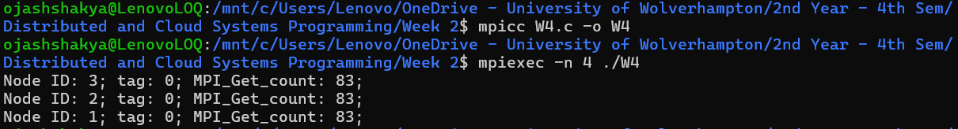

Explanation: Process 0 receives data from all other processes as this MPI application dynamically allots memory for data transfer. A random number of data pieces are created by each process (rank > 0), sent to Process 0, and the matching data is subsequently sent. Process 0 gets the data size first, uses malloc() to allocate memory appropriately, and then gets the actual data from each process. Following processing, it releases the allocated memory after printing the sender's rank, tag, and the size of the received data. By dynamically allocating just the necessary space for each data transmission, this guarantees effective memory usage.

Assessed Workshop Task
5. The file "WarAndPeace.txt" on Canvas contains the entire text of the book "War and Peace" by Leo Tolstoy. Write an MPI program to count the number of times each letter of the alphabet occurs in the book. Count both the upper case and the lowercase as the same. Ignore any letter with accents such as " é " and so on.
Your MPI program should work with any number of processes from 1 to 100 processes. Only Process rank 0 (zero) should read in the file and send the appropriate chunk of file to each other process. The other processes should not read in the file.
You should submit this program as "workshoptask1.c" as part of your final portfolio submission. You can also upload it to the formative submission point for formative feedback.
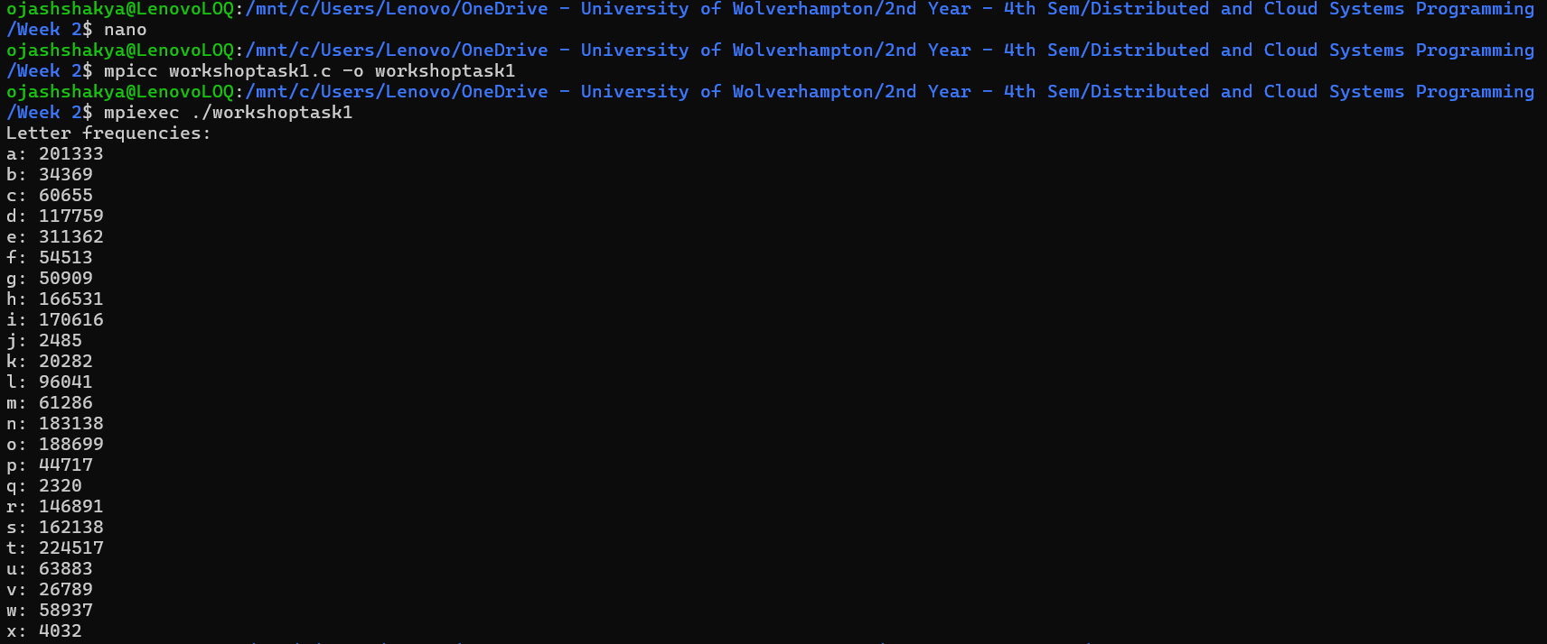

Explanation: This MPI-based C program divides the burden across several processes to determine how frequently each letter appears in War and Peace. Parts of the text are sent to other processes by the root process (rank 0), which reads the full file and determines the chunk size. The count_letters function, which increases counts for each alphabetic character (ignoring case), is used by every process, including the root, to count the letters in its allocated chunk. The root process then publishes the final letter frequencies after combining the local counts from each process into global counts using MPI_Reduce and a summing operation. This parallel method uses numerous processors to speed up the processing.

